NAME: CHRISTINA JOSE MANAKKAL

ROLL NO: 48 PID: 191064 CLASS: TEITB

St. Francis Institute of Technology, Mumbai-400 103

**Department Of Information Technology**

A.Y. 2021-2022

Class: TE-IT B, Semester: V

Subject: **DevOps Lab**

**Experiment – 2: To understand version control system/ source code management, install git and create a GitHub account**

1. **Aim:** To understand version control using Git and create a GitHub account
2. **Objectives:** Aim of this experiment is that, the students will be able

* To be aware of different Version Control tools like GIT and GitHub
* To obtain complete knowledge of the “version control system” to effectively track changes augmented with Git and GitHub

1. **Outcomes:** After study of this experiment, the students will be able to

* GIT Installation
* Version Control
* Working with remote repository

1. **Prerequisite:** Knowledge of software engineering concept of version control
2. **Requirements:** Git,Personal Computer, Windows operating system, browser, Internet Connection, Microsoft Word.
3. **Pre-Experiment Exercise:**

**Brief Theory:** Refer shared material

1. **Laboratory Exercise**
   * + 1. **Procedure:**

**a. Answer the following:**

* Explain version control and its types

1. Git is a Version Control System or VCS. VCS is basically software designed

to record changes within one or more files over time. It is designed to handle

everything from small to very large projects with speed and efficiency.

2. The types of VCS are:

i. Local Version Control System

A local version control system is a local database located on your

local computer, in which every file change is stored as a patch.

ii. Centralized Version Control System

A centralized version control system has a single server that

contains all the file versions.

iii. Distributed Version Control System

With distributed version control systems, clients don’t just check

out the latest snapshot of the files from the server, they fully mirror

the repository, including its full history.

* What is Git and GitHub?

1. Git is a mature, actively maintained open source project originally developed in 2005 by Linus Torvalds, the famous creator of the Linux operating system kernel. A staggering number of software projects rely on Git for version control, including commercial projects as well as open source. Developers who haveworked with Git are well represented in the pool of available software development talent and it works well on a wide range of operating systems and IDEs

2. GitHub is a provider of Internet hosting for software development and version control using Git. It offers the distributed version control and source code management functionality of Git, plus its own features. It provides access control and several collaboration features such as bug tracking, feature requests, task management, continuous integration and wikis for every project. Headquartered in California, it has been a subsidiary of Microsoft since 2018.

* Explain different Git commands

**1. git init**

The git init command is used to convert an existing, unversioned project to a Git repository or initialize a new, empty repository.

**2. git status**

The git status command displays the state of the working directory and the staging area.

**3. git config**

With Git, there are many configurations and settings possible. git config is how to assign these settings. Two important settings are user user.name and user.email.

**4. git add**

The git add command adds a change in the working directory to the staging area.

**5. git commit**

The git commit command captures a snapshot of the project's currently staged changes. Files in the staging area (untracked files) can be tracked using “commit” command.

**6. git log**

To show the chronological commit history for a repository. This helps give context and history for a repository. git log is available immediately on a recently cloned repository to see history.

**7. git push**

The git push command is used to upload local repository content to a remote repository.

**8. git fetch**

Let’s say some other programmer in your team makes a commit to the remote branch master, and you need to pull those changes down to our local (fetch operation). When you fetch, git syncs the changes with your origin/master. It will not bring it on to your master branch, until you merge it.

**9. git merge**

Integrate branches together. git merge combines the changes from one branch to another branch. For example, merge the changes made in a staging branch into the stable branch.

**b**. **Execute following on Git and GitHub (Refer the shared material) and attach screenshots:**

* Git installation

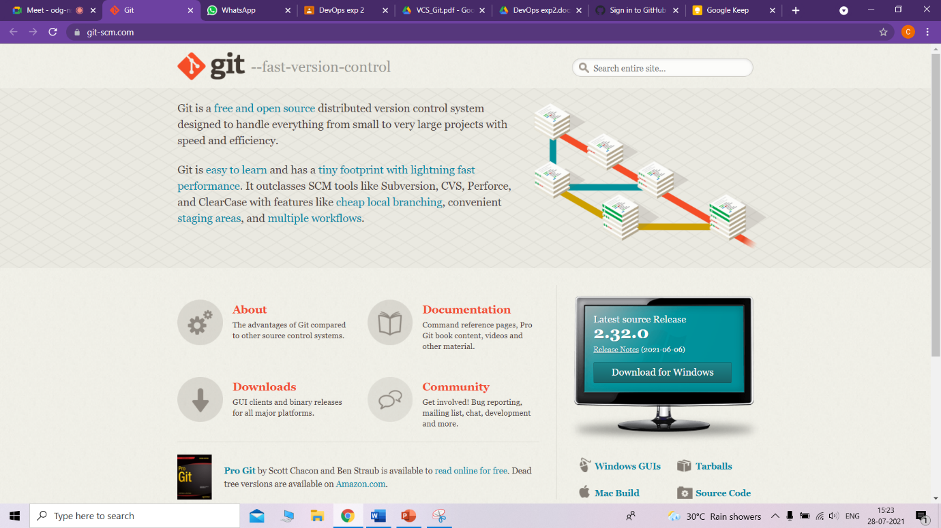

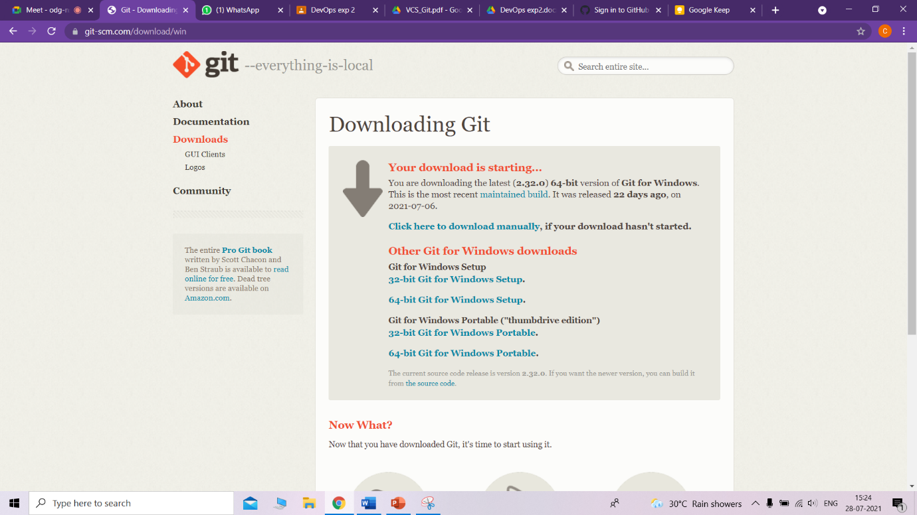

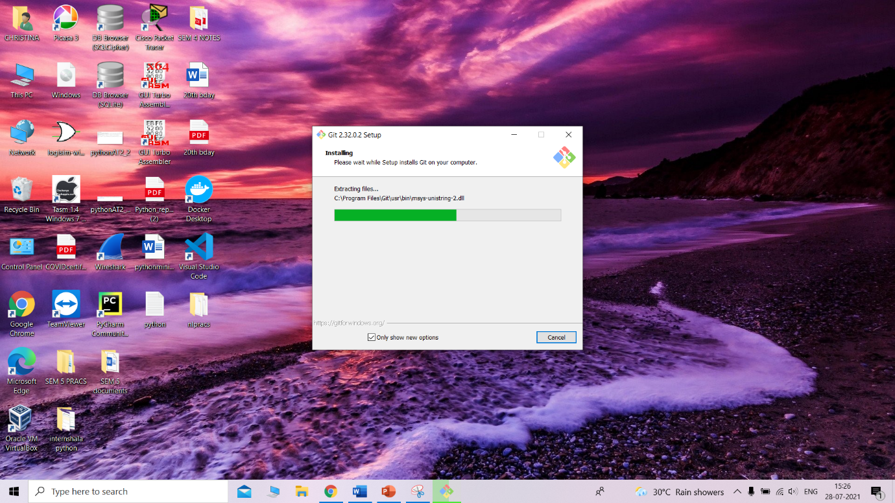

* Git commands

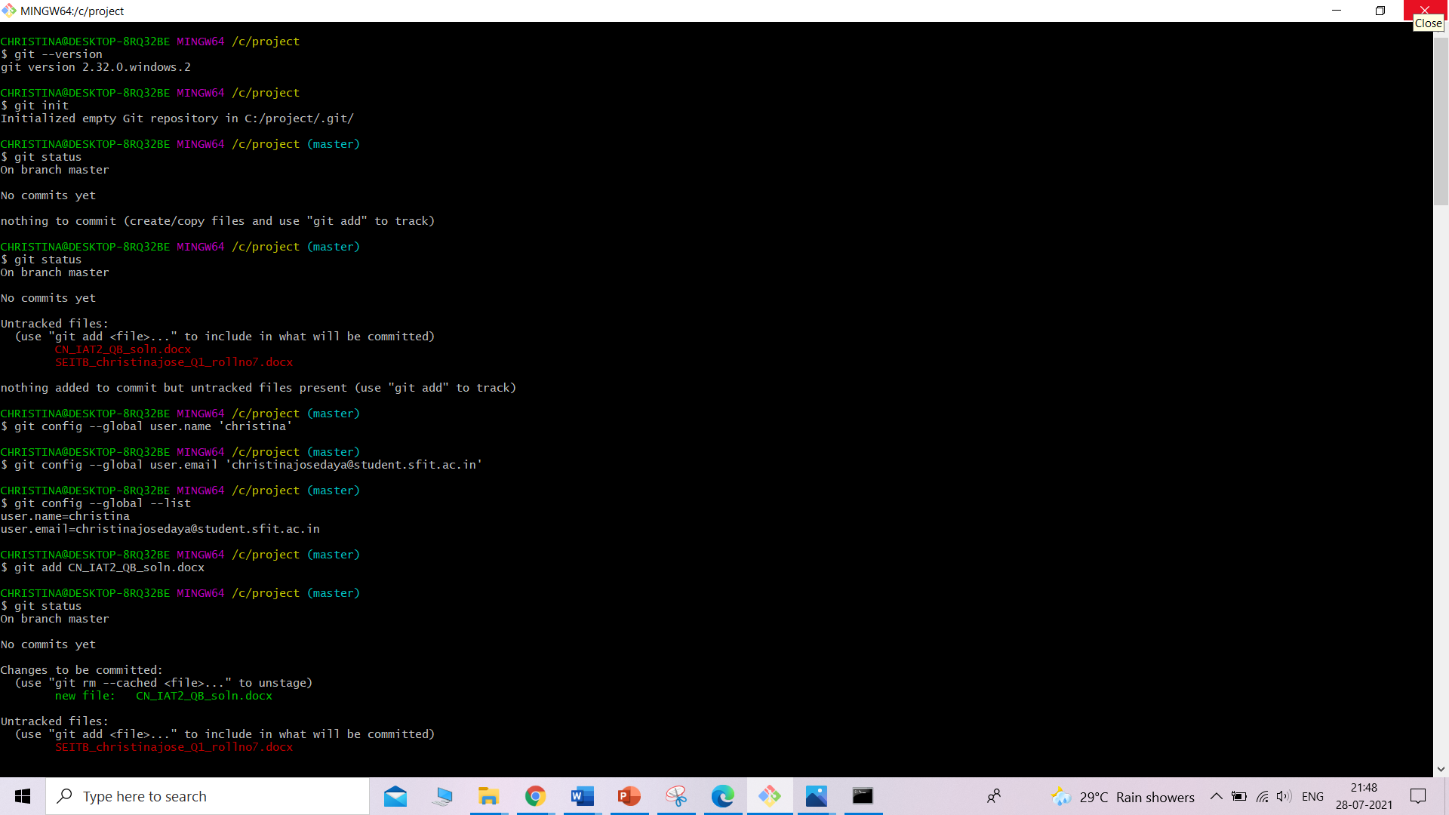

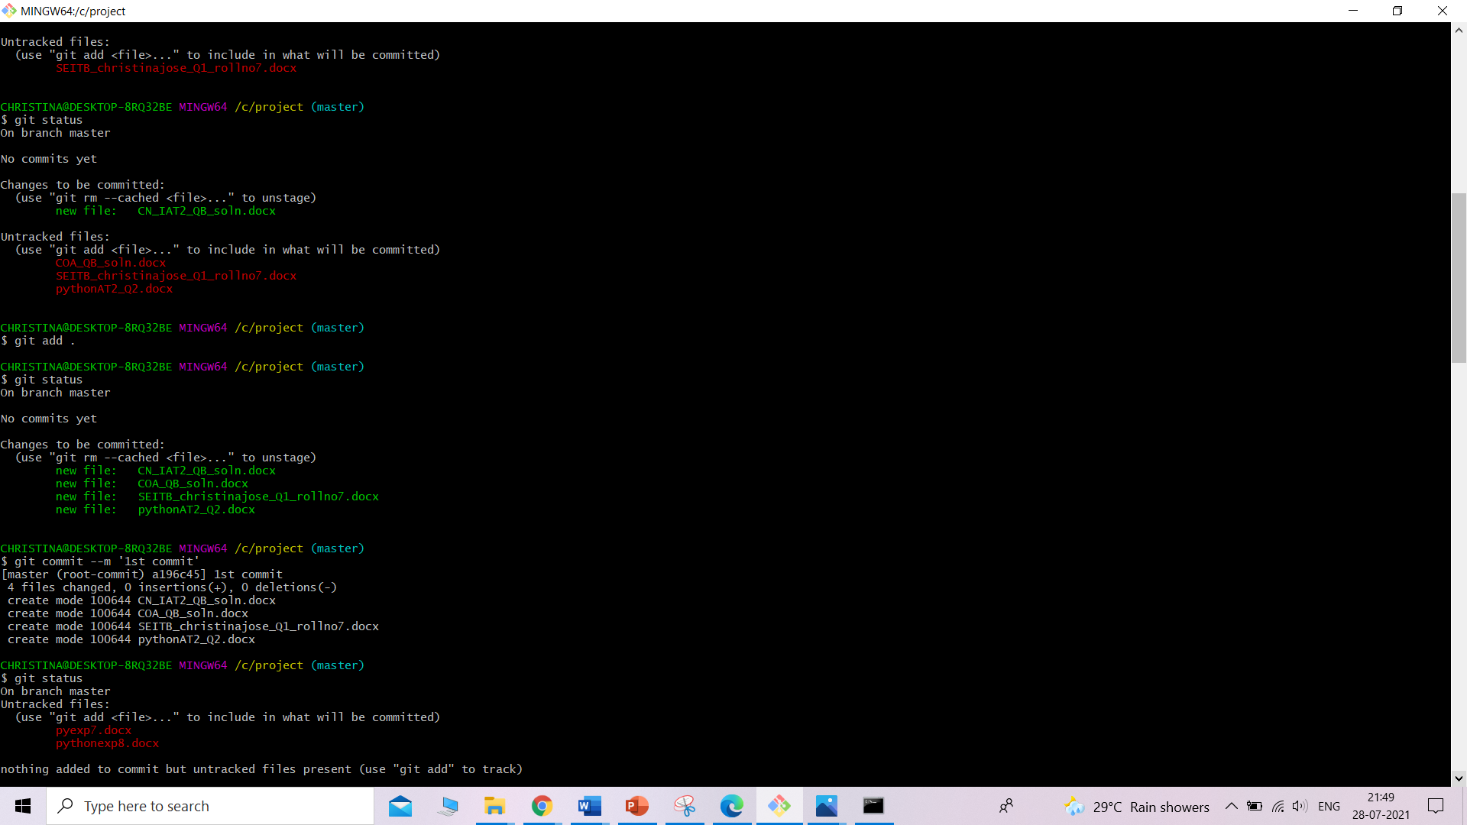

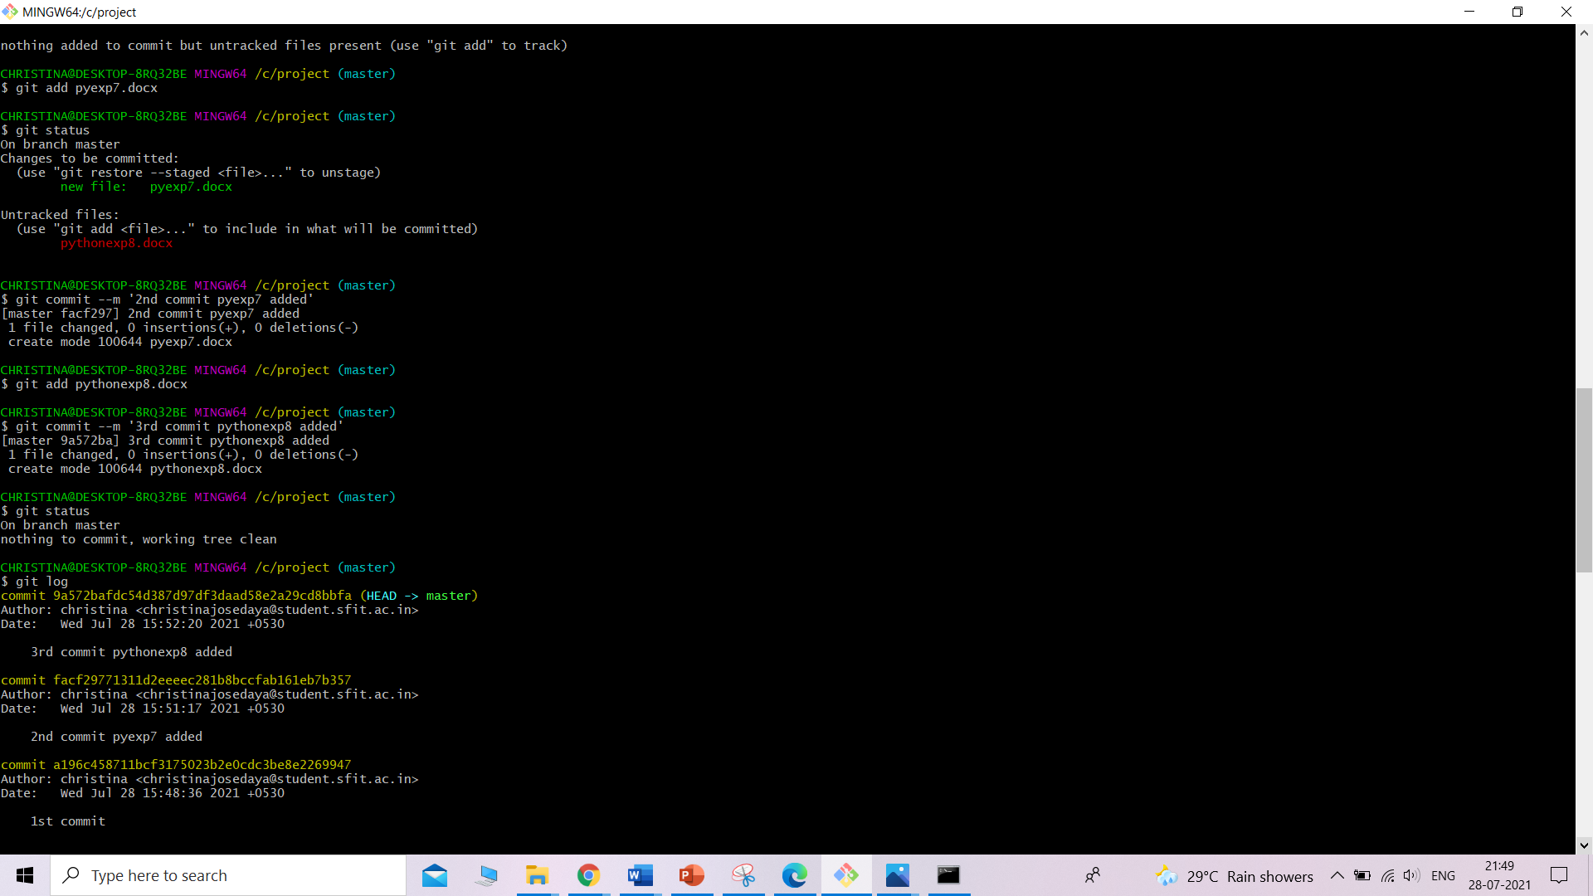

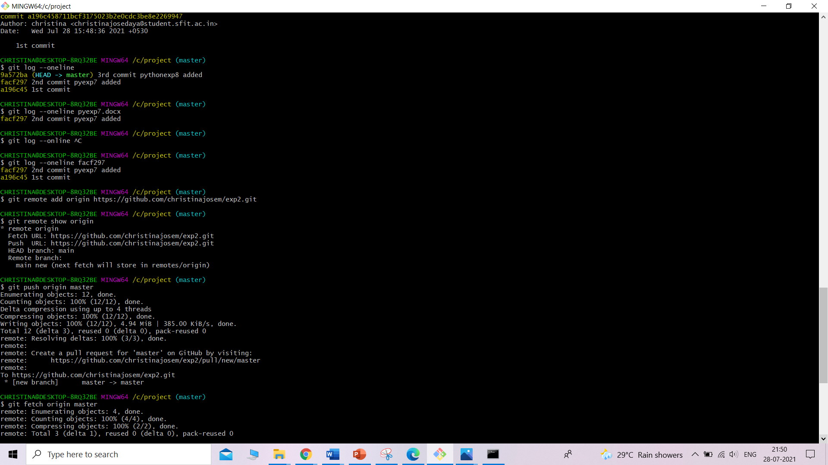

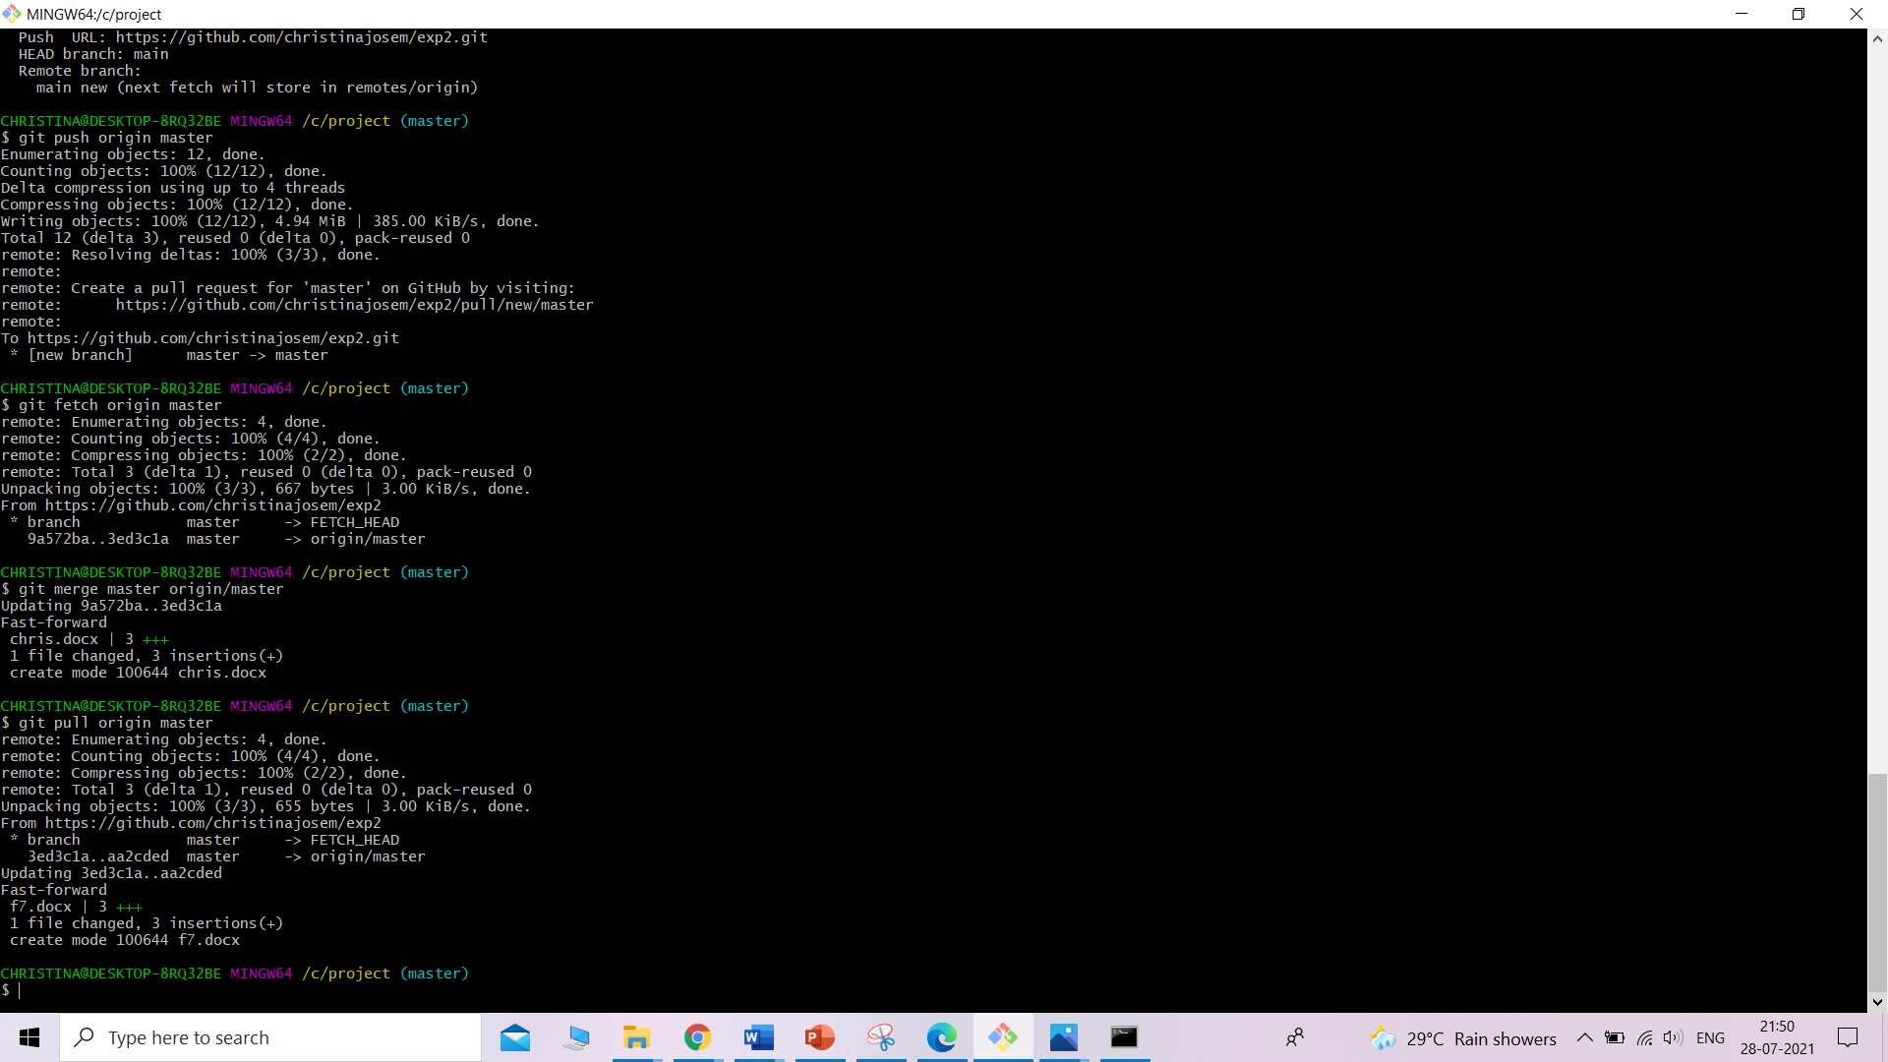

* GitHub account creation

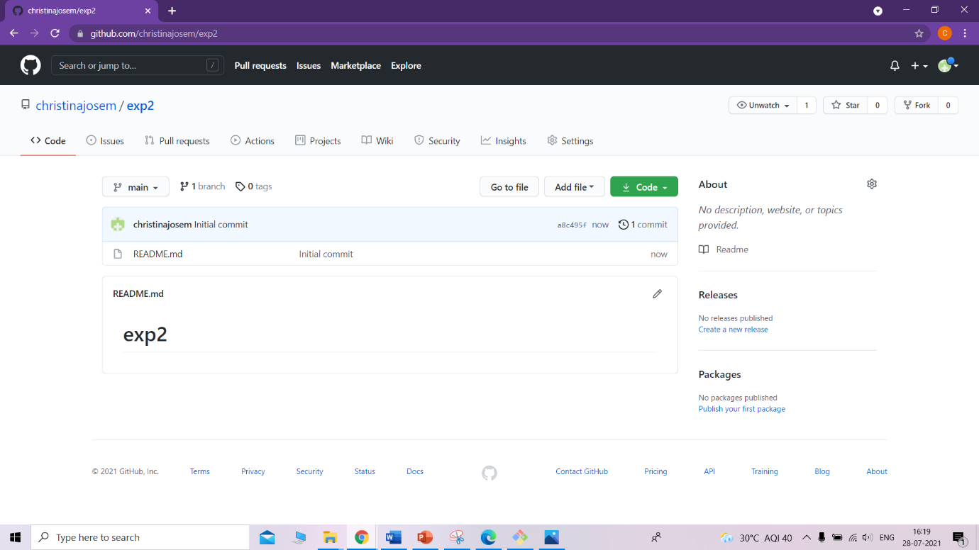

1. **Post-Experiments Exercise**
2. **Extended Theory:**

Nil

1. **Questions:**

* What are the different Git areas? Explain with diagram
* What is a Git conflict?

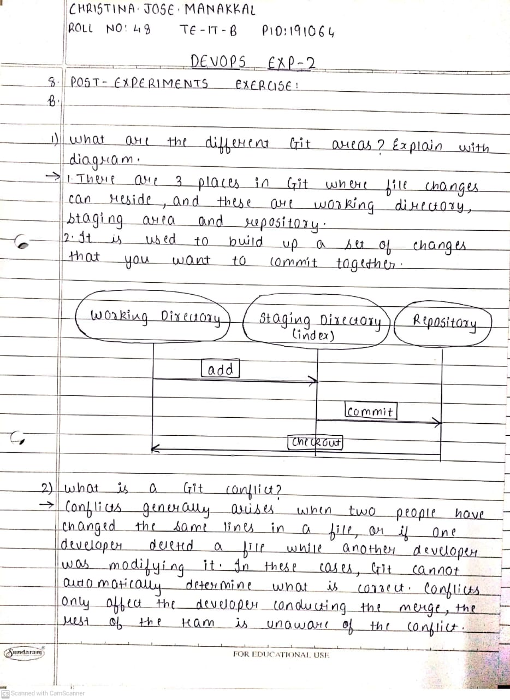

1. **Conclusion:**

* Write what was performed in the experiment.
* Write the significance of the topic studied in the experiment.

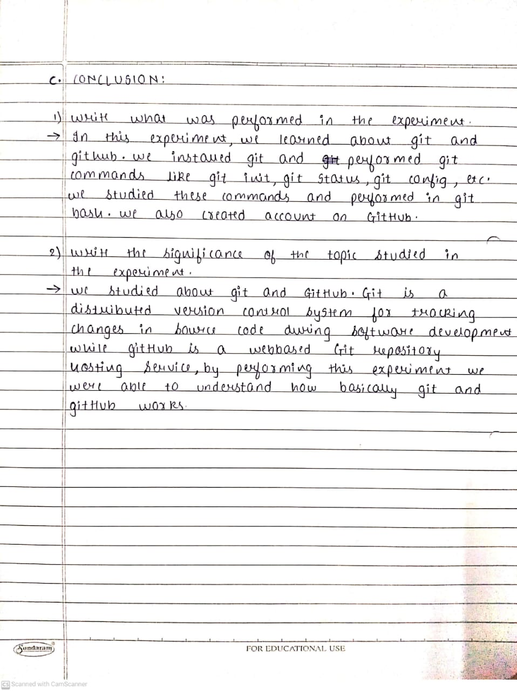

1. **References:**

[**https://github.com/**](https://github.com/)

[**https://guides.github.com/activities/hello-world/**](https://guides.github.com/activities/hello-world/)

[**https://git-scm.com/docs/gittutorial**](https://git-scm.com/docs/gittutorial)